WINCHESTER HOCKEY CLUB
JUNIOR SECTION

2024-2025

MIXED U10 GROUP
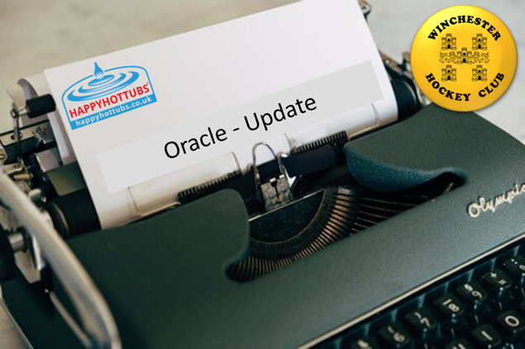

VISION

We aim to offer an inclusive and welcoming environment where we can provide hockey for as wide a range of children as possible, whilst also stretching those who are driven to achieve their full potential.

OBJECTIVES

- Provide a combination of an inclusive participation offering and talent development.
- Ensure training and match environments are always safe and fun.
- Enter 2 teams (one boys and one girls) into the in-2-hockey competitions.
- Enter as many teams as possible into local friendly fixtures & festivals.
- Encourage hockey participation in our local area.
- Continually enhance the quality of coaching to all members.

SQUAD STATUS

We have experienced exceptional demand for places in the squad. Our current membership includes 70 players that will be eligible for next season’s U10 squad comprising:
- 30 existing U10 players (10 boys; 20 girls) that will still be U10s
- 21 current U8 players (8 boys; 13 girls) that will move up to the U10s
- 19 players (5 boys; 14 girls) on a waiting list, most of whom have been training with our introductory group

We expect more membership enquiries as a result of our ongoing outreach activities.

The squad has been “full” for the 2023-24 season, restricted by the maximum number of players that can be accommodated on the pitch during training. We have provided a partial solution by establishing an introductory group, which trains alongside the U8s, and invites those players that cannot be accommodated in the U10 group.

We are proposing a restructuring of the squad for 2024-25, so that we can accommodate more children.

SQUAD STRUCTURE

The squad will operate as 2 sub-groups.

The starting point for allocation will be by school year – Winchester Scorpions will comprise players in year 4 (U9s) & Winchester Pumas will comprise players in year 5 (U10s). However, in the interest of ensuring that the children are playing in the environment that is most suitable for them, the most advanced year 4 players may be invited to join Winchester Pumas.

Both squads will train at Kings School, on Sunday mornings at the following times:
- Scorpions: 9am – 10.30am
- Pumas: 10.30am-12pm

Players from both squads will be invited to play in fixtures & festivals against other local clubs.

The in-2-hockey championship teams will be selected from the Pumas’ squad.

COACHING & MANAGEMENT

Squad lead coach: Ally Birch
Squad manager: J Russell

Scorpions – Lead Coach: [ ]
Pumas – Lead Coach: Ally Birch

The squad manager will be responsible for overall co-ordination of the U10 group.
The squad lead coach will be responsible for supporting other coaches so that all training sessions deliver a high level of coaching.

COACH DEVELOPMENT

The junior section director of coaching and the squad lead coach will arrange regular coach education sessions, with the aim of developing confident coaches who can deliver high quality training sessions to all of our players.

